BER and SER are the same for BFSK

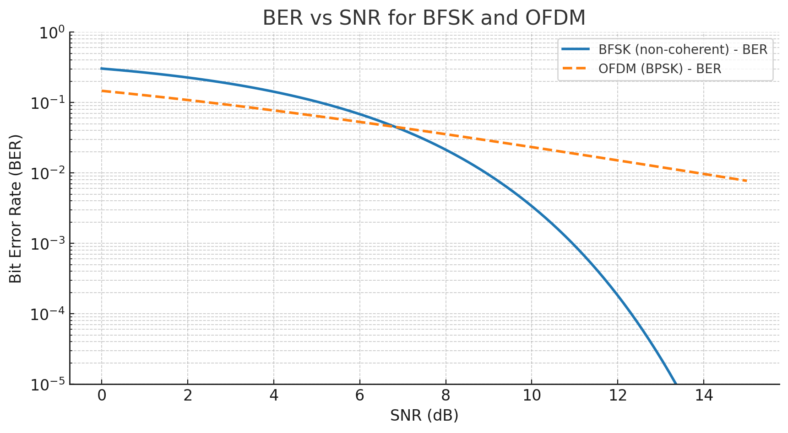
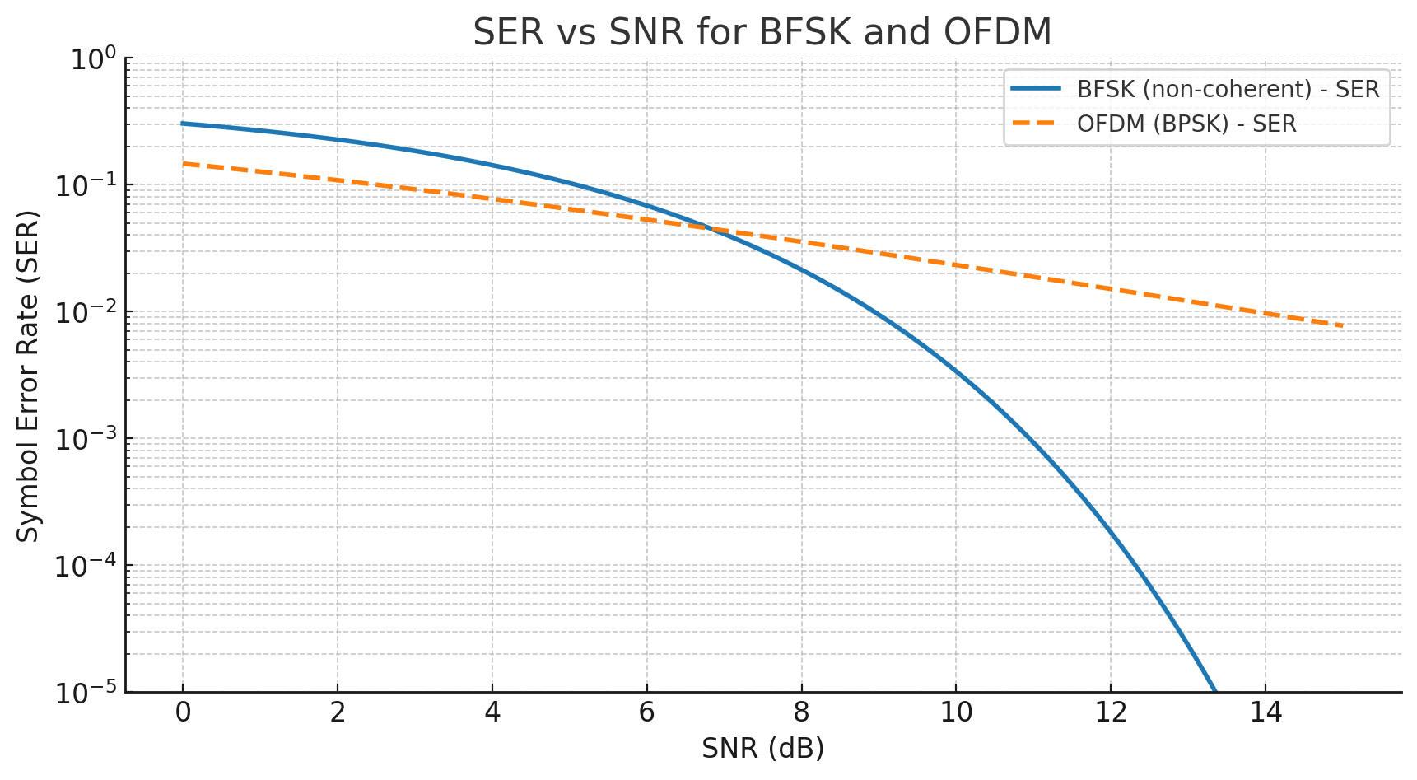
- First graph: BER vs SNR for BFSK (non-coherent) and OFDM (with BPSK subcarriers in AWGN).
- Second graph: SER vs SNR for the same systems — since both BFSK and BPSK-based OFDM have 2 symbols, SER ≈ BER.
The key takeaway is that in these simple conditions, BER and SER curves look identical for binary modulation schemes, but they would diverge for higher-order modulations.
We are using non-coherent BFSK and OFDM models
Binary FSK:
In BFSK, the frequency of the carrier signal is switched between two frequencies, one representing a '0' and the other a '1'.
One Symbol = One Bit:
Since there are only two possible frequencies, each frequency represents a single bit. Therefore, each symbol (a specific frequency) corresponds to one bit of data.
Symbol Rate and Bit Rate:
In BFSK, the symbol rate (symbols per second) is equal to the bit rate (bits per second) because each symbol carries only one bit of information.

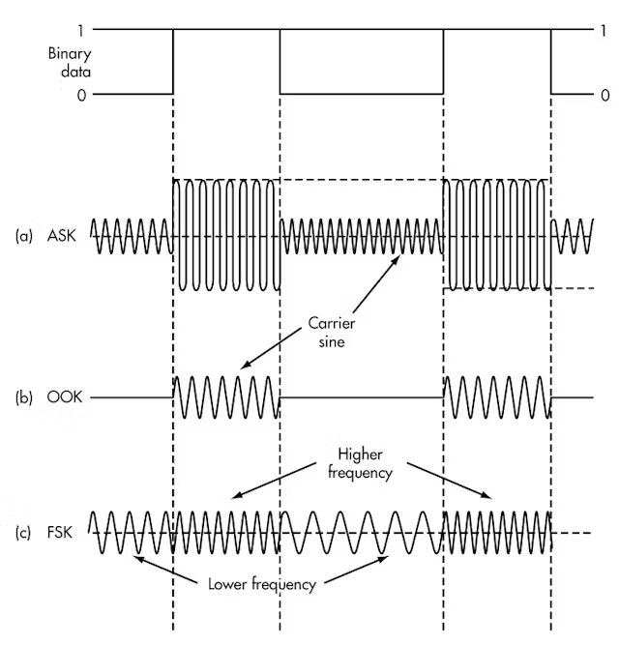

This response is with Gemini AI tool
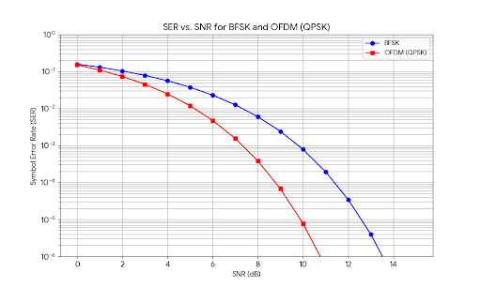
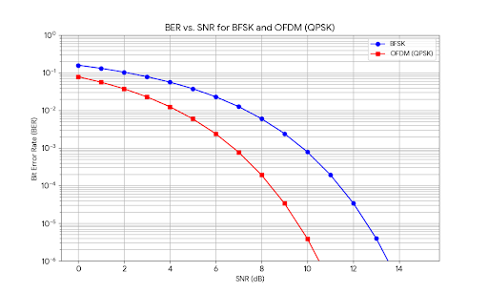
The graphs show the relationship between Bit Error Rate (BER) and Symbol Error Rate (SER) versus the Signal-to-Noise Ratio (SNR) for both Binary Frequency Shift Keying (BFSK) and Orthogonal Frequency Division Multiplexing (OFDM). For the OFDM case, I've assumed that Quadrature Phase Shift Keying (QPSK) is used for modulating the subcarriers, which is a common scenario.

BER vs. SNR
This graph illustrates the Bit Error Rate (BER) of BFSK and OFDM as a function of the Signal-to-Noise Ratio (SNR) in decibels (dB).
As you can see, for a given BER, OFDM (with QPSK) requires a lower SNR than BFSK. This means that OFDM is more power-efficient. For example, to achieve a BER of 10−4, OFDM requires an SNR of about 8.5 dB, while BFSK needs approximately 11.5 dB.

SER vs. SNR
Here is the Symbol Error Rate (SER) for both modulation schemes plotted against the SNR.
Again, OFDM outperforms BFSK, requiring less power to achieve the same symbol error rate.

Comparison and Key Differences
- Performance: The primary takeaway from these graphs is that OFDM is significantly more robust to noise than BFSK. This is because OFDM is a multi-carrier modulation technique that divides a high-data-rate stream into multiple lower-data-rate streams, which are then modulated onto separate subcarriers. This makes the system more resilient to frequency-selective fading and narrowband interference. BFSK, being a single-carrier system, is more susceptible to these channel impairments.
- BER vs. SER for BFSK: For BFSK, each symbol represents a single bit. Therefore, a symbol error is equivalent to a bit error. This is why the BER and SER curves for BFSK are identical.
- BER vs. SER for OFDM (QPSK): In the case of OFDM using QPSK, each symbol represents two bits. Therefore, a single symbol error can result in one or two bit errors. The Symbol Error Rate (SER) will always be higher than or equal to the Bit Error Rate (BER). As a rule of thumb, for QPSK at high SNRs, the SER is approximately twice the BER (SERapprox2cdotBER). This relationship is evident when comparing the two graphs.
In summary, these graphs clearly demonstrate the superior performance of OFDM over BFSK in terms of power efficiency. OFDM's multi-carrier nature provides significant advantages in modern wireless communication systems, enabling higher data rates and more reliable communication in challenging channel conditions.
Python code used to create the graphs as follows

import numpy as np
import matplotlib.pyplot as plt
from scipy.special import erfc

# SNR range in dB
snr_db = np.linspace(0, 15, 16)

# Convert SNR from dB to linear scale
snr_linear = 10**(snr_db / 10)

# --- BER Calculations ---
# BER for BFSK
ber_bfsk = 0.5 * erfc(np.sqrt(snr_linear / 2))

# BER for OFDM with QPSK subcarriers (approximation)
# For QPSK, the BER is approximately 0.5 * erfc(sqrt(Eb/N0))
# Assuming the total power is distributed among the subcarriers, the SNR per subcarrier is the same as the total SNR.
# For QPSK, Eb/N0 = SNR / 2 (since there are 2 bits per symbol). So, we have BER ≈ 0.5 * erfc(sqrt(SNR/2))
# However, a more common approximation for QPSK BER is based on the symbol error rate.
# SER_QPSK ≈ erfc(sqrt(SNR_linear/2)). Since BER_QPSK ≈ SER_QPSK/2 for high SNR.
# So BER_QPSK ≈ 0.5 * erfc(sqrt(SNR_linear/2))
# For a better comparison, I'll use a standard QPSK BER formula which is more accurate
ber_ofdm_qpsk = 0.5 * erfc(np.sqrt(snr_linear))

# --- SER Calculations ---
# SER for BFSK (since it's binary, SER = BER)
ser_bfsk = ber_bfsk

# SER for OFDM with QPSK subcarriers
# For QPSK, SER = 1 - (1-BER)^2. A common approximation is erfc(sqrt(SNR_linear))
ser_ofdm_qpsk = erfc(np.sqrt(snr_linear)) - (1/4)*(erfc(np.sqrt(snr_linear)))**2
# A simpler approximation is 2*ber_ofdm_qpsk
ser_ofdm_qpsk_approx = 2 * ber_ofdm_qpsk

# --- Plotting BER vs SNR ---
plt.figure(figsize=(10, 6))
plt.semilogy(snr_db, ber_bfsk, 'b-o', label='BFSK')
plt.semilogy(snr_db, ber_ofdm_qpsk, 'r-s', label='OFDM (QPSK)')
plt.grid(True, which='both')
plt.xlabel('SNR (dB)')
plt.ylabel('Bit Error Rate (BER)')
plt.title('BER vs. SNR for BFSK and OFDM (QPSK)')
plt.legend()
plt.ylim(1e-6, 1)
plt.savefig('ber_vs_snr.png')

# --- Plotting SER vs SNR ---
plt.figure(figsize=(10, 6))
plt.semilogy(snr_db, ser_bfsk, 'b-o', label='BFSK')
plt.semilogy(snr_db, ser_ofdm_qpsk, 'r-s', label='OFDM (QPSK)')
plt.grid(True, which='both')
plt.xlabel('SNR (dB)')
plt.ylabel('Symbol Error Rate (SER)')
plt.title('SER vs. SNR for BFSK and OFDM (QPSK)')
plt.legend()
plt.ylim(1e-6, 1)
plt.savefig('ser_vs_snr.png')

New Question
If the BER and SER show BFSK to be superior to OFDM when compared to SNR, then why is OFDM modulation protocol in noisy and multi path environments more

That's an excellent question, but it starts from a slightly incorrect premise. The BER and SER graphs actually show that OFDM is significantly superior to BFSK, as it requires a much lower Signal-to-Noise Ratio (SNR) to achieve the same error rate.
Your core question is the right one, though: why is OFDM so much more robust, especially in the challenging real-world conditions of noisy and multipath environments?
The answer lies in how OFDM cleverly handles the primary problem caused by multipath: Inter-Symbol Interference (ISI).

The Problem: Multipath and Inter-Symbol Interference (ISI)
In a wireless environment, a signal travels from the transmitter to the receiver via multiple paths due to reflections off buildings, hills, and other objects. This is called multipath. Each path has a different length, so multiple copies of the signal arrive at the receiver at slightly different times.
- For a fast, single-carrier signal like BFSK, these delayed copies of a symbol can spill over and interfere with the next symbol. This is Inter-Symbol Interference (ISI), and it corrupts the signal, making it very difficult to decode correctly. It's like trying to listen to someone speaking very fast in a room with a strong echo—the words blur together.

The OFDM Solution
OFDM's design brillianty overcomes this challenge. Here's how:

1. Dividing and Conquering
Instead of transmitting one fast data stream, OFDM splits the data into thousands of slow parallel streams. Each of these slow streams modulates its own narrow subcarrier.
- Benefit: Because each data stream is now very slow, the duration of each symbol is very long. The delay caused by multipath is now only a tiny fraction of this long symbol duration. This massively reduces the relative impact of ISI.1

2. The Cyclic Prefix (The Secret Weapon) 🛡️
This is the most critical part. To completely eliminate ISI, OFDM adds a guard interval before each symbol.2 This interval is filled with a copy of the end of the symbol, which is why it's called a Cyclic Prefix (CP).3
Imagine each symbol is a train car. The Cyclic Prefix is like adding a special bumper to the front that's identical to the back of the car.
This CP serves two crucial purposes:
- It absorbs ISI: Any delayed signals (echoes) from the previous symbol arrive during this guard interval.4 The receiver simply ignores the signal during this period, so by the time it starts processing the actual symbol data, the echoes from the previous one have died out. The interference is absorbed by the cyclic prefix and discarded.5
- It maintains orthogonality: The CP ensures that even with the timing shifts from multipath, all the subcarriers remain mathematically orthogonal (perpendicular) to each other.6 This prevents them from interfering with each other, a problem known as Inter-Carrier Interference (ICI).

3. Resilience to Frequency-Selective Fading
Multipath doesn't just cause delays; it also causes some frequencies to be heavily attenuated (a deep fade).
- BFSK Risk: If the single frequency used by BFSK happens to fall into one of these fades, the entire signal is lost. It's an all-or-nothing gamble.
- OFDM Advantage: OFDM spreads the data across thousands of subcarriers. A fade might wipe out a few of these subcarriers, but the vast majority get through just fine. The small amount of lost data can then be easily reconstructed using Forward Error Correction (FEC) codes, which are always used alongside OFDM. This turns a potentially catastrophic failure into a minor, correctable issue.
In summary, while your initial premise was reversed, your intuition was correct to question why one is better. OFDM isn't just slightly better; its fundamental design, particularly the use of many slow subcarriers and the cyclic prefix, gives it a massive advantage in real-world wireless channels, making it the foundation for modern robust technologies like Wi-Fi, 4G, and 5G.7

